RFID-BASED INDUSTRIAL INVENTORY MANAGEMENT SYSTEM

A PROJECT REPORT SUBMITTED
IN PARTIAL FULFILLMENT OF THE REQUIREMENTS FOR
MDC-AI-401 | MDC-CS-401 | MDC-AI-601 | MDC-CS-601
BACHELOR OF TECHNOLOGY
Minor Degree Course in
Electronics and Communication Engineering
SEMESTER IV

Submitted by | [Harshvardhan Singh, Yugraj singh]
Roll Number(s) | [2024a3r016,2024a3r021]
Program / Branch / Section | B.Tech [ECE]
Minor Degree Course | [Industry 4.0]
Semester | [IV ]
Course Coordinator / Faculty In-charge | [Mr. Bhanu Partap Singh Jamwal]
Submission Date | [06JUNE2026]

SUBMITTED TO
Department of Computer Science and Engineering
Model Institute of Engineering and Technology (Autonomous)
Kot Bhalwal, Jammu, India
(NAAC "A" Grade Accredited)
2026

CERTIFICATE
This is to certify that the project report entitled RFID-Based Inventory Management System submitted by [Harshvardhan Singh , Yugraj Singh] is a record of the work carried out for the Minor Degree Course MDC-CS-401 | RFID-Based Inventory Management System during Semester IV. The work has been completed under the guidance/supervision of the undersigned and is recommended for academic evaluation.
Date | 06JUNE2026 | Signature of Faculty In-charge
Place | MIET JAMMU | Name | Mr. Bhanu Partap Singh Jamwal

STUDENT DECLARATION
We hereby declare that this report is based on the project/course work carried out by us for the Minor Degree Course. All external sources, datasets, images, code libraries, APIs, open-source tools, websites, research papers, and generative AI assistance, if used, have been properly acknowledged. We also declare that this work has not been submitted elsewhere for academic credit.
Student Name | Roll Number | Branch / Section | Signature
[HarshVardhan Singh] | [ 2024a3r016] | [ECE ]
[Yugraj Singh ] | [2024a3r021 ] | [ECE ]

ABSTRACT

This project focuses on RFID-based industrial inventory management, addressing the problems of manual stock tracking such as inaccuracy, delays, and inefficiency in warehouse operations. The objective is to design a smart and automated system that enables real-time identification and monitoring of inventory items using RFID technology. The proposed approach uses an ESP32 microcontroller integrated with an RFID reader and RFID tags, where each product is assigned a unique identifier for fast and contactless scanning. When an item is detected, the system verifies its authenticity and updates its status instantly. LEDs and a buzzer are used to provide visual and audio feedback for authorized or unauthorized access. The system improves inventory control by reducing human effort and minimizing errors in data entry and stock handling. The output shows efficient item tracking, quick response time, and improved reliability in warehouse management. This work is useful for modern industries aiming to implement low-cost and efficient RFID-based automation systems for better inventory accuracy and operational efficiency.

KEYWORDS

[RFID Technology, Inventory Management System, ESP32 Microcontroller, Automation, Industrial Monitoring, Real-time Tracking]

TABLE OF CONTENTS
The following reduced structure is recommended for Minor Degree Course students of Semester IV and VI. It keeps the report concise while retaining the essential academic and technical components.
Section | Recommended Length | Page No.
Certificate and Student Declaration | 1 page | ii
Abstract | 1 page | iii
Chapter 1: Project Overview | 1 page | 1
Chapter 2: Background and Tools Used | 1 page | 2
Chapter 3: Design and Implementation | 2-3 pages | 3
Chapter 4: Results, Testing and Discussion | 1-2 pages | 6
Chapter 5: Conclusion and Future Scope | 1 page | 8
References | 0.5-1 page | 9
Appendix, if required | Optional | 10

GENERAL FORMATTING AND WRITING RULES
Item | Recommended Rule
Target report length | Semester IV: 8-10 pages including preliminary pages. Semester VI: 10-12 pages including preliminary pages. Appendices may be additional if permitted.
Paper and margins | A4, portrait orientation, 1 inch margins. Add binding margin only if hard binding is required.
Font and spacing | Times New Roman, 11 or 12 pt body text, 1.15 or 1.5 line spacing, consistent paragraph spacing.
Headings | Chapter headings: 14 pt bold. Section headings: 12 pt bold. Use simple decimal numbering: 1, 1.1, 1.2.
Figures and tables | Use only relevant screenshots/diagrams. Explain every figure/table in the text. Avoid oversized screenshots.
Code snippets | Show only short and meaningful snippets in the main report. Full code should be in GitHub/appendix if required.
Citation style | Use IEEE numeric style [1], [2] unless the course faculty specifies another style.
Submission hygiene | Check grammar, plagiarism, citations, formatting, figure clarity, and page numbering before submission.

ACADEMIC INTEGRITY RULE
Do not copy text from websites, previous reports, GitHub readme files, or AI tools without rewriting, understanding, and citing appropriately. A good Minor Degree Course report should explain what was learned, designed, implemented, tested, and concluded.

CHAPTER 1: PROJECT OVERVIEW

Background and Motivation
Inventory management is a critical function in industries, warehouses, and retail sectors where accurate tracking of goods is essential for smooth operations. Traditional manual methods such as barcode scanning and register-based entry are time-consuming and prone to human errors, leading to stock mismatches, delays, and financial losses. With the advancement of Industry 4.0 technologies, RFID (Radio Frequency Identification) has emerged as a reliable solution for real-time and contactless item tracking. This project is suitable for the Minor Degree Course as it combines embedded systems, automation, and communication technologies. It helps bridge theoretical knowledge with practical implementation using ESP32, RFID modules, and basic electronic components, making it highly relevant for modern industrial applications.

Problem Statement
Traditional inventory systems are inefficient due to manual errors, slow processing, and lack of real-time updates. Barcode systems also require line-of-sight scanning, which reduces efficiency. There is a need for a low-cost, automated, and reliable system that can track items instantly without manual intervention. This project addresses these issues using RFID technology for fast and accurate inventory management.

1.3 Objectives

• To design and develop an RFID-based inventory management system using ESP32.
• To implement real-time item identification using RFID tags and reader.
• To provide LED and buzzer alerts for authorized and unauthorized access.
• To test system performance in terms of accuracy and speed.1.4 Scope and Expected Learning Outcomes
This project is limited to a small-scale RFID-based inventory system for basic tracking and verification. It does not include cloud or large database integration. The project helps in learning ESP32 programming, RFID interfacing, circuit design, and system testing. It also provides practical exposure to automation and industrial IoT concepts.

CHAPTER 2: BACKGROUND AND TOOLS USED.

2.1 Essential Background
RFID (Radio Frequency Identification) is used for automatic identification of objects using radio waves. It consists of RFID tags and a reader that captures the tag’s unique ID. ESP32 microcontroller processes this data and controls output devices like LED and buzzer. This project is based on basic RFID principles and embedded system concepts used in automation and inventory tracking.

2.2 Tools, Technologies and Dataset / Input Used
Category | Details
Programming Language | C (Arduino IDE)
Framework / Library | SPI.h , MFRC522
Hardware | ESP32, RFID Reader, RFID Tags, LED, Buzzer
Dataset / Input Source | RFID Tag UID
Tools | Arduino IDE, Breadboard, Jumper Wires

2.3 Mini Gap / Need Analysis
Existing Approach / Source | Main Feature | Limitation / Need | Project Response
Manual Inventory System | Paper-based stock tracking | Slow, error-prone, no real-time update | RFID-based automated tracking
Barcode System | Scanning-based identification | Requires line-of-sight and manual scanning | Contactless RFID detection using tags
Basic RFID System | Item identification using RFID | No alert or monitoring system | ESP32 with LED and buzzer alerts for status indication

CHAPTER 3: DESIGN AND IMPLEMENTATION

3.1 Functional Requirements
3.1 Functional Requirements
Req. ID | Requirement | Priority
FR-01 | The system shall read RFID tags using an RFID reader module. | High
FR-02 | The system shall verify the scanned RFID tag UID for authorization. | High
FR-03 | The system shall display status using LED and buzzer indicators. | Medium
FR-04 | The system shall process and update inventory status using ESP32 microcontroller. | High

3.2 Methodology / Workflow

First, the RFID reader scans the tag attached to an item and sends its unique ID (UID) to the ESP32. The ESP32 checks this UID with the stored authorized list. If it matches, the item is accepted; if not, it is rejected. The system then shows the result using LED lights and a buzzer for easy indication. The output can also be seen on the serial monitor for testing. Finally, the system is tested by scanning different tags to check accuracy and proper working. [Explain the step-by-step working of the solution: input, processing, algorithm/model/business logic, storage, output, testing, and deployment/demo.]

3.3 System Architecture / Workflow Diagram[Insert one clean and readable architecture/workflow diagram here.]
RFID Tag (Input)
↓
RFID Reader (MFRC522)
↓
ESP32 Microcontroller
↓
UID Verification (Processing Logic)
↓
Decision Making
↓ ↓
Authorized Unauthorized
↓ ↓
Green LED Red LED + Buzzer
↓
Serial Monitor / Output Display

3.4 Module Description
Module | Responsibility | Input / Output
RFID MODULE | READS RFID TAGS | INPUT : RFID TAG,OUTPUT:UID
ESP32 CONTROLLER | PROCESSES AND VERIFIES DATA | Input: UID, Output: Decision
OUTPUT MODULE | SHOWS SYSTEM STSTUS | Input: Decision, Output: LED & Buzzer indication

3.5 Key Implementation Details

The system is implemented using ESP32 microcontroller programmed through Arduino IDE. RFID tags are scanned using MFRC522 module, which sends UID data to ESP32. The UID is compared with predefined authorized values in the code. Based on verification, the system triggers LED and buzzer for indication. Serial Monitor is used for real-time testing and debugging. The system is powered via USB and tested on a breadboard setup for demonstration.

3.6 Important Code
#include <SPI.h>
#include <MFRC522.h>
#define SS_PIN D8
#define RST_PIN D0
#define GREEN_LED D4
#define RED_LED D1
#define BUZZER D2
MFRC522 mfrc522(SS_PIN, RST_PIN);
String validUID = "13 19 DA 2C";
void setup() {
Serial.begin(115200);
SPI.begin();
mfrc522.PCD_Init();
pinMode(GREEN_LED, OUTPUT);
pinMode(RED_LED, OUTPUT);
pinMode(BUZZER, OUTPUT);
digitalWrite(GREEN_LED, LOW);
digitalWrite(RED_LED, LOW);
Serial.println("RFID Inventory System Ready 1");
Serial.println("Scan RFID Tag...");
}
void loop() {
if (!mfrc522.PICC_IsNewCardPresent())
return;
if (!mfrc522.PICC_ReadCardSerial())
return;
String tagID = "";
for (byte i = 0; i < mfrc522.uid.size; i++) {
if (mfrc522.uid.uidByte[i] < 0x10)
tagID += "0";
tagID += String(mfrc522.uid.uidByte[i], HEX);
tagID += " ";
}

tagID.trim();
tagID.toUpperCase();
Serial.print("UID: ");
Serial.println(tagID);
if (tagID == validUID) {
Serial.println("ITEM FOUND");
digitalWrite(GREEN_LED, HIGH);
tone(BUZZER, 1000);
delay(300);
noTone(BUZZER);
delay(1000);
digitalWrite(GREEN_LED, LOW);
} else {
Serial.println("UNKNOWN ITEM");
digitalWrite(RED_LED, HIGH);
for (int i = 0; i < 3; i++) {
tone(BUZZER, 3000);
delay(500);
noTone(BUZZER);
}
digitalWrite(RED_LED, LOW);
}
Serial.println("------------------");
mfrc522.PICC_HaltA();
}

CHAPTER 4: RESULTS, TESTING AND DISCUSSION

4.1 Test Cases
Test ID | Scenario | Input | Expected Output | Result
TC-01 | Valid RFID tag scanned | Authorized UID | [Expected] | PASS
TC-02 | Invalid RFID tag scanned | Unauthorized UID | [Expected] | PASS

4.2 Output Screens / Experimental Results
The system was tested using multiple RFID tags to verify correct identification. When an authorized tag is scanned, the green LED turns ON indicating successful access. For unauthorized tags, the red LED and buzzer activate as an alert. The serial monitor displays real-time UID values and system status, confirming correct processing by ESP32.
Fig. 4.1: Representative output/result of the project
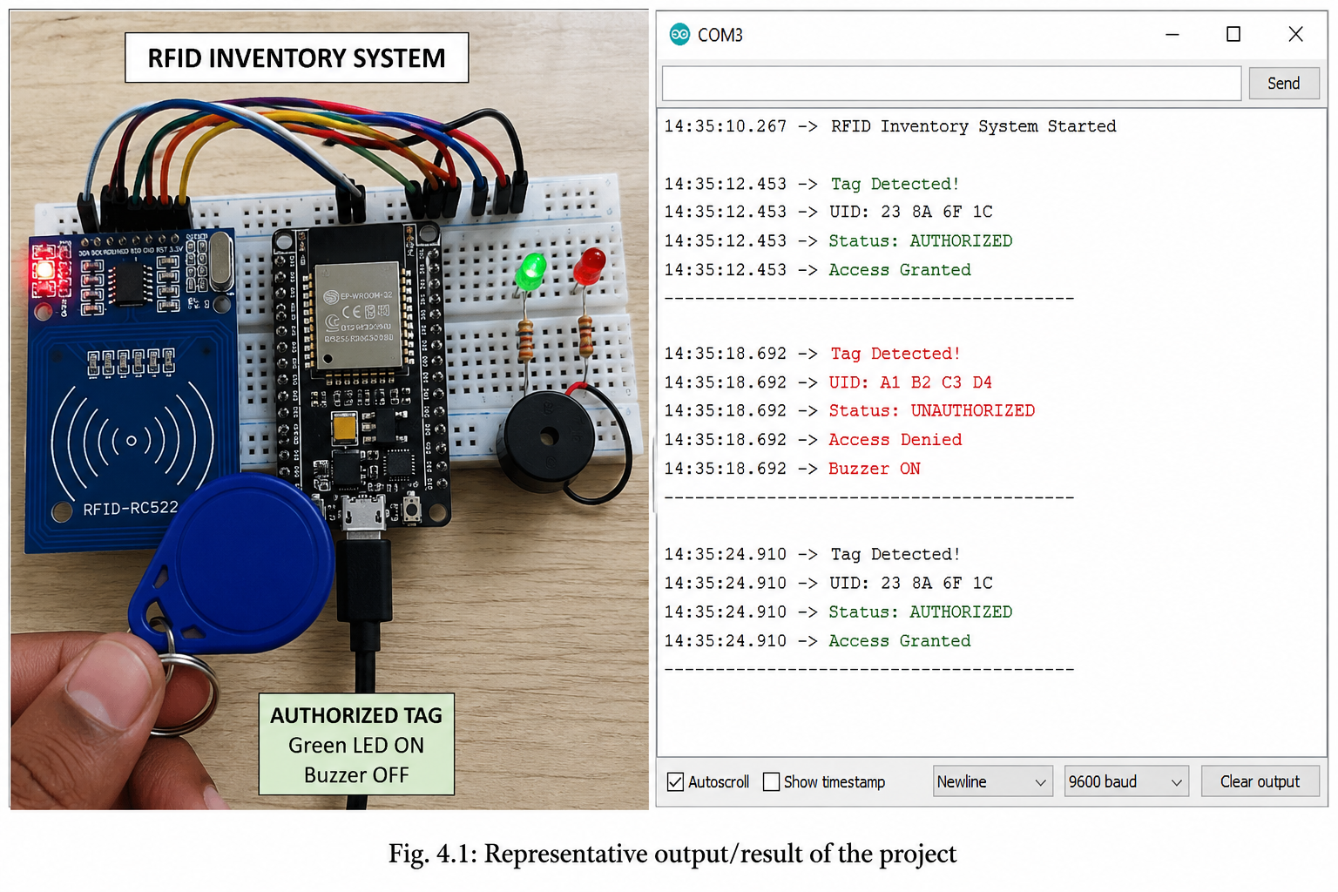

4.3 Discussion and Observation
The system successfully meets all defined objectives by accurately identifying RFID tags and providing instant feedback through LED and buzzer indicators. The response time is fast, and the system works reliably for repeated scans. No major errors were observed during testing, although RFID detection range depends on tag positioning and distance. The project demonstrates good accuracy, simple usability, and effective real-time monitoring. Overall, the results confirm that the RFID-based inventory system is efficient for small-scale automation and improves traditional manual tracking methods.

CHAPTER 5: CONCLUSION AND FUTURE SCOPE

5.1 Conclusion

The RFID-based inventory management system was successfully designed and implemented using ESP32, RFID reader, RFID tags, LED, and buzzer modules. The system fulfills the main objectives of real-time item identification, automated verification, and status indication. During implementation, RFID tags were scanned and processed efficiently by the ESP32, which correctly differentiated between authorized and unauthorized items.

The testing results show that the system works reliably with quick response time and accurate detection. It reduces manual effort and improves inventory tracking efficiency, making it suitable for small-scale industrial applications. Overall, the project helped in understanding embedded systems, RFID technology, and real-time automation concepts.

5.2 Limitations
• The system works only in a small-range and controlled environment.
• It uses a predefined UID list, so it is not connected to a cloud or database system.
• Performance may be affected by interference or improper tag positioning.
• Limited scalability for large industrial inventory systems.

5.3 Future Scope
• Integration with cloud database for real-time inventory tracking across locations.
• Development of a mobile or web dashboard for better monitoring and control.
• Addition of data analytics for stock prediction and usage tracking.
• Implementation of role-based access and enhanced security features.

5.4 Ethical, Security and Social Considerations
This system ensures basic security by restricting access using authorized RFID tags, reducing unauthorized entry or misuse of inventory. User data (UIDs) should be stored securely to prevent cloning or unauthorized duplication of tags. The system must be used responsibly in industrial environments without violating privacy norms. From a social perspective, automation improves efficiency and reduces human workload, but it should be designed to support workers rather than replace them completely. Proper safety and ethical usage ensure reliable and fair deployment of RFID-based systems.

REFERENCES

[1] K. Finkenzeller, RFID Handbook: Fundamentals and Applications in Contactless Smart Cards, Radio Frequency Identification and Near-Field Communication, 3rd ed. Wiley, 2010.

[2] Espressif Systems, “ESP32 Technical Reference Manual,” 2024. [Online]. Available: https://www.espressif.com/en/products/socs/esp32. Accessed: 06 June 2026.

[3] MFRC522 RFID Module Datasheet, NXP Semiconductors, 2016. [Online]. Available: https://www.nxp.com/docs/en/data-sheet/MFRC522.pdf. Accessed: 06 June 2026.

[4] Arduino, “Arduino SPI Library Documentation,” 2024. [Online]. Available: https://docs.arduino.cc/libraries/spi/. Accessed: 06 June 2026.

[5] GitHub, “MFRC522 RFID Library for Arduino,” open-source project. [Online]. Available: https://github.com/miguelbalboa/rfid. Accessed: 06 June 2026.

APPENDIX A: OPTIONAL SUPPORTING MATERIAL
A.1 Code Summary
The main program is written in C using Arduino IDE. It initializes the RFID reader, reads UID from tags, compares it with predefined authorized IDs, and controls LED and buzzer outputs accordingly.
A.2 Hardware Setup
The system uses ESP32, MFRC522 RFID reader, RFID tags, LED indicators, and a buzzer connected via breadboard using jumper wires.
A.3 Testing Notes
Testing was performed using multiple RFID tags to verify correct authorization handling and system response under real-time conditions.

FINAL SUBMISSION CHECKLIST
Check | Status
Title is specific and matches actual work. | [ ] Done
Cover page contains correct minor course name, course code, semester, branch/section, and faculty details. | [ ] Done
Certificate and declaration are complete and signed by all group members. | [ ] Done
Abstract states problem, method, output/result, and relevance. | [ ] Done
Objectives are measurable and reflected in results/conclusion. | [ ] Done
Background/tools are concise and properly cited. | [ ] Done
Architecture/workflow diagram is readable and explained. | [ ] Done
Implementation section explains important decisions, not only code. | [ ] Done
Test cases/results are presented and discussed. | [ ] Done
Figures and tables are numbered and referred to in the text. | [ ] Done
References follow a consistent style. | [ ] Done
External code, datasets, APIs and AI tools are acknowledged. | [ ] Done
Grammar, formatting, alignment and page numbering have been checked. | [ ] Done

BASIS OF THIS MODIFIED TEMPLATE
This modified template is adapted from the attached B.Tech CSE project report template and reduced for Minor Degree Course students of Semester IV and VI. The earlier seven-chapter structure has been compressed into five focused chapters to make the report more suitable for course-level project documentation while retaining essential academic components: title page, certificate/declaration, abstract, concise background, design and implementation, results/testing, conclusion, references, and checklist.

